Program: BE Electronics Engineering
Curriculum Scheme: Revised 2012
Examination: Third Year Semester VI
Course Code: EXC 601 and Course Name: VLSI DESIGN
SAMPLE QB
Time: 1 hour Max. Marks: 50
==============================================================================
Note to the students: - All the Questions are compulsory and carry equal marks.
Q1. | In CMOS fabrication which type of substrate is used
Option A: | P type substrate
Option B: | N type substrate
Option C: | Can be N type or P type
Option D: | T type
Q2. | In layout diagram which material is used for gate
Option A: | Polysilicon
Option B: | Si
Option C: | Ge
Option D: | GaAs
Q3. | The abbreviation designation of input current with low input is
Option A: | VIH
Option B: | VOH
Option C: | VIL
Option D: | VOL
Q4. | Which parameter is not used in noise margin
Option A: | VIH
Option B: | VOH
Option C: | VIL
Option D: | IOL
Q5. | In voltage transfer characteristics of MOSFET inverter V_{IH} indicates
Option A: | Cut off point
Option B: | Critical point
Option C: | Saturation point
Option D: | Depletion point
Q6. | MOSFET stands for
Option A: | metal oxide semiconductor field effect transistor
Option B: | metal oxide silicon field effect transistor
Option C: | Metal semiconductor field effect transistor
Option D: | Metal oxygen field effect transistor
Q7. | Channel creation is done in
Option A: | Accumulation region
Option B: | depletion
Option C: | Cut off
Option D: | inversion
Q8. | Correct symbol of CMOS inverter
Option A: | 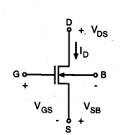
Option B: | 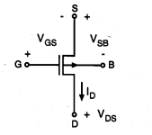
Option C: | 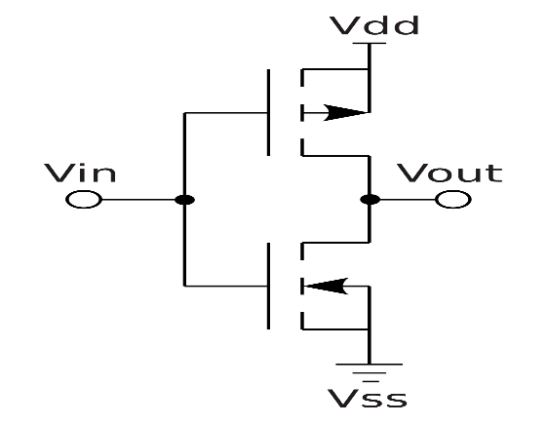
Option D: | 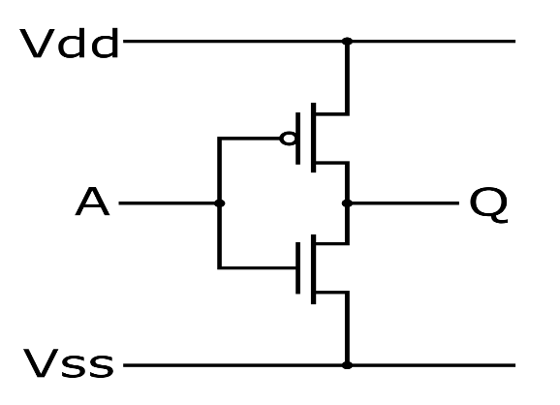
Q9. | Channel length modulation parameter is
Option A: | λ
Option B: | Ω
Option C: | Δ
Option D: | β
Q10. | CCMOS stands for
Option A: | Complementary CMOS
Option B: | Clocked CMOS
Option C: | Control CMOS
Option D: | Complementary symmetry CMOS
Q11. | In CCMOS logic
Option A: | One PMOS & one NMOS with opposite clocks are connected between load & driver
Option B: | Only one PMOS transistor is used with gate at ground
Option C: | Only one NMOS transistor is used with any input
Option D: | Only one NMOS transistor is used gate at ground
Q12. | Which logic just pass the signals
Option A: | Pass transistor
Option B: | Transmission gate
Option C: | CPL (complementary pass transistor logic)
Option D: | OR gate
Q13. | Toggle condition occurs in
Option A: | D FF
Option B: | T FF
Option C: | J K Flip Flop
Option D: | S R latch
Q14. | Which tree is used in clock distribution
Option A: | A
Option B: | B
Option C: | C
Option D: | H
Q15. | Zipper is
Option A: | Dynamic logic
Option B: | Domino logic
Option C: | Zipper
Option D: | N-P domino logic
Q16. | PROM is
Option A: | Programmable ROM
Option B: | Primary ROM
Option C: | Static RAM
Option D: | Volatile RAM
Q17. | Difference between static & dynamic CMOS
Option A: | Both are same
Option B: | In static clock is used
Option C: | In dynamic logic clock is used
Option D: | Extra transistors are used in static RAM
Q18. | CMOS behaves like
Option A: | AND GATE
Option B: | OR
Option C: | NOT
Option D: | EXOR
Q19. | Which architecture is used to design VLSI
Option A: | System on device
Option B: | Single open circuit
Option C: | System on chip
Option D: | System on a circuit
Q20. | Which provides higher integration density?
Option A: | Switch transistor logic
Option B: | Transistor buffer logic
Option C: | Transistor transistor logic
Option D: | System on device
Q21. | Charge sharing problem occurs in
Option A: | Dynamic logic
Option B: | Pseudo logic
Option C: | Static
Option D: | CCMOS
Q22. | RCA vs CLA
Option A: | delay of RCA is high
Option B: | Delay of CLA is high
Option C: | delay of both are same
Option D: | there is no delay in RCA
Q23. | D flip flop is also called as
Option A: | Delay flip flop
Option B: | dead flip flop
Option C: | deadline flip flop
Option D: | Double flip flop
Q24. | In realization of Y=A+B how many transitors are required?
Option A: | 6
Option B: | 4
Option C: | 5
Option D: | 1
Q25. | In realization of Y=A*B how many transitors are required?
Option A: | 6
Option B: | 4
Option C: | 5
Option D: | 1

